**Lab 5 Exercise** Due on: Sunday Noon

**There are two parts in this lab. Each part has 2.5 points.**

***Part 1***

Please create a database that implements the following ERD model for the Syracuse Airways database (see below).

As the model shows: the company has many airplanes which are of different specifications (e.g. Boeing 777, Airbus A320, and so on). Each aircraft specification has the same attributes, such as aircraftVersion, cabin number of seats and fuel capacity. The airplanes are assigned to diverse flight routes. Each flight route has a unique flight number, departs and arrives at particular airports at different cities in scheduled time. Every day the airplanes work according to their flight routes, but the flight schedule may be affected by flight statuses (on time, delay, or cancelled).



Please use SQL DDL to provide the following deliverables that satisfy three major requirements.

1. Create tables:

Create the eight tables following the ERD above. Copy and paste the complete create statements to your lab report. Make sure you set up correct constraints for the primary keys and foreign keys. Also the following domain constrains are required in the creating:

***States Table***

|  |  |  |  |  |
| --- | --- | --- | --- | --- |
| Primary/Foreign Key | Attribute | Data Type | Required | Domain Constraint |
| PK | stateAbbr | VARCHAR(2) | Y |  |
|  | stateName | VARCHAR(20) | Y |  |

***City Table***

|  |  |  |  |  |
| --- | --- | --- | --- | --- |
| Primary/Foreign Key | Attribute | Data Type | Required | Domain Constraint |
| PK | cityID | CHAR(8) | Y |  |
|  | cityName | VARCHAR(25) | Y |  |
| FK | stateAbbr | VARCHAR(2) | Y |  |

***Airport Table***

|  |  |  |  |  |
| --- | --- | --- | --- | --- |
| Primary/Foreign Key | Attribute | Data Type | Required | Domain Constraint |
| PK | airportID | CHAR(3) | Y |  |
|  | airportName | VARCHAR(45) | Y | UNIQUE |
| FK | cityID | CHAR(8) | Y |  |

***FlightRoute Table***

|  |  |  |  |  |
| --- | --- | --- | --- | --- |
| Primary/Foreign Key | Attribute | Data Type | Required | Domain Constraint |
| PK | flightNumber | VARCHAR(6) | Y |  |
| FK | departAirport | CHAR(3) | Y |  |
| FK | arriveAirport | CHAR(3) | Y |  |
|  | scheduledDepartTime | TIME | Y |  |
|  | scheduledArrivalTime | TIME | Y |  |

***FlightSchedule Table***

|  |  |  |  |  |
| --- | --- | --- | --- | --- |
| Primary/Foreign Key | Attribute | Data Type | Required | Domain Constraint |
| PK, FK | flightNumber | VARCHAR(6) | Y |  |
| PK | flightDate | DATE | Y |  |
| FK | statusID | CHAR(1) | Y | Value=”O”, “D” or “C” |
| FK | airplaneID | CHAR(8) | Y |  |
|  | delayDepartTime | TIME | N |  |
|  | delayArrivalTime | TIME | N |  |

***FlightStatus Table***

|  |  |  |  |  |
| --- | --- | --- | --- | --- |
| Primary/Foreign Key | Attribute | Data Type | Required | Domain Constraint |
| PK | statusID | CHAR(1) | Y | Value=”O”, “D” or “C” |
|  | description | VARCHAR(20) | Y |  |

***Airplane Table***

|  |  |  |  |  |
| --- | --- | --- | --- | --- |
| Primary/Foreign Key | Attribute | Data Type | Required | Domain Constraint |
| PK | airplaneID | CHAR(8) | Y |  |
| FK | aircraftTypeID | CHAR(8) | Y |  |
|  | purchaseDate | DATE | Y | Default=”01/02/2014” |

***AircraftSpecs Table***

|  |  |  |  |  |
| --- | --- | --- | --- | --- |
| Primary/Foreign Key | Attribute | Data Type | Required | Domain Constraint |
| PK | aircraftTypeID | CHAR(8) | Y |  |
|  | aircraftVersion | VARCHAR(10) | Y |  |
|  | cabinNumOfSeats | INT | N |  |
|  | fuelCapacity | INT | Y |  |

1. Insert data:

Insert the following data (shown in the screenshots) to the tables. Copy and paste all insert statements to the lab report. **You need to insert exact data as shown, because the same data will be used in future labs.**

1. Select data:

Select all content of each table to prove the success of creating tables and inserting data. Include the screenshots of the select results in the lab report.

**\*Note: In Airport table, Enter your last name as first entry of airportName column. Don’t change values for airportID and cityID.**

The select results should look like follows:

States table:

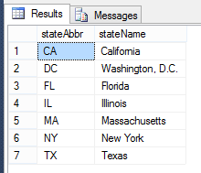

City table:

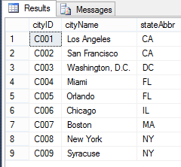

Airport Table:

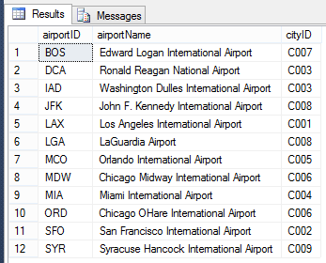

**\*Note: In Airport table, Enter your last name as first entry of airportName column. Don’t change values for airportID and cityID.**

FlightRoute table:

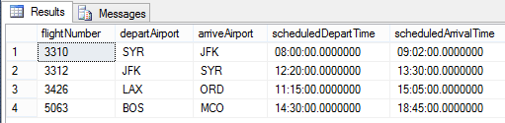

FlightStatus table:

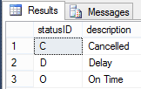

AircraftSpecs table:

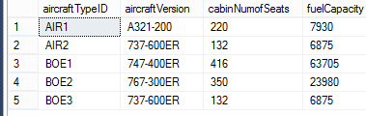

Airplane table:

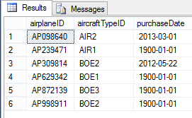

FlightSchedule table:

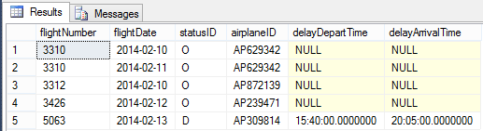

***Part 2***

**Using the above tables and data, write queries to answer the following questions**

**QUESTIONS**: Table Queries

1. Find all aircrafts whose fuel capacity is less than 63705. Show aircraft id, cabin number of seats and fuel capacity.
2. Find all airplanes which were on time or delayed. Show only airplane ID, flight date and statusID.
3. Find all the airplanes that have been purchased before the year 2013-02-10. Show airplane id and the purchase Date.

**Submission instruction**

Please submit your lab report (including SQL statements, and the screenshots of SQL statements and their results) in **one PDF** or **Word** file to Black Board. Make sure your screenshots have good resolution. Remember to add comments to your SQL statements to explain the purpose of the code blocks. Name your file in this format “IST659-Lab5-Lastname-Firstname.PDF”.

Grading Criteria:

-1 for each missed query

-0.5 for each wrong query/result

-0.25 for each missed screenshot of result/query

**Due date**

The lab report is due on Sunday Noon